Katherine Banis  
CMPSC 497  
Lab #7: Red and Blue Color Detection with OpenCV and Python  
10.17.2024

**Objective:** Create a program in Python using HSV and OpenCV to detect red and blue objects; only detecting the largest object if multiple red or blue objects.

**Materials:** Python with OpenCV (used PyCharm), red and blue objects

**Pseudocode:**

Helper Function: find_largest_contour(mask)  
 input: binary mask image # red or blue mask  
 find contours in mask  
 if any contours:  
 detect largest contour based on area  
 computer moments of largest contour  
 if moment’s area is non-zero:  
 compute centroid (cx, cy)  
 return largest contour and centroid  
 if no contours found, return None

Cap = VideoCapture

While():

Read current frame  
Convert frame from BGR to HSV  
Define HSV range for blue:  
 lower blue: [100, 100, 100]  
 upper blue: [130, 255, 255]  
Define HSV range for red:  
 lower red: [0, 120, 70]  
 upper red: [10, 255, 255]   
Create binary mask for blue (mask_blue)  
Create binary mask for red (mask_red)  
Combine blue and red masks using bitwise OR  
Find the largest blue object  
 call find_largest_contour(blue_mask)  
 if blue object is found:  
 draw largest blue contour on frame in blue  
 draw a circle at the centroid  
 display text: “Blue Centroid” at location of centroid  
Find the largest red object  
call find_largest_contour(red_mask)  
 if blue object is found:  
 draw largest red contour on frame in red  
 draw a circle at the centroid  
 display text: “Red Centroid” at location of centroid  
Display frame with text  
Check for esc key: if esc key is pressed, exit loop.

cv.destroyAllWindows: release video capture, close any OpenCV windows

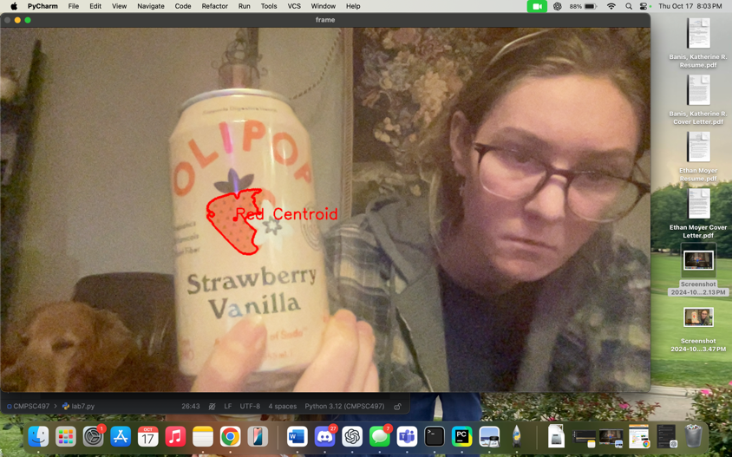**Test Cases and Results:**

Test 1:

The OLIPOP strawberry vanilla soda can with a red strawberry and red font.

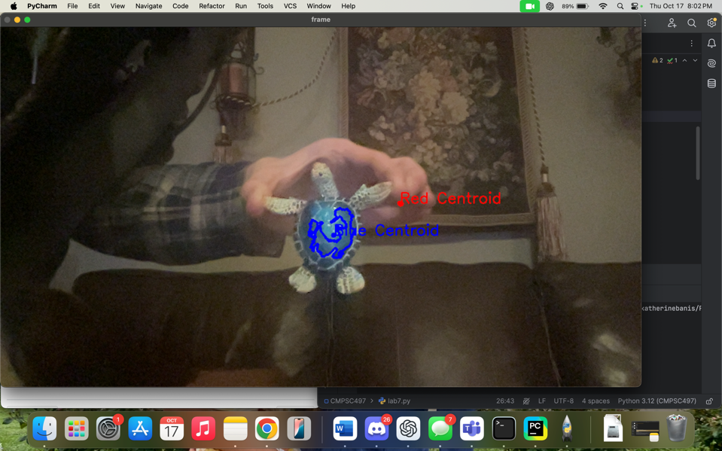

Test 2:

Turtle with a blue shell.

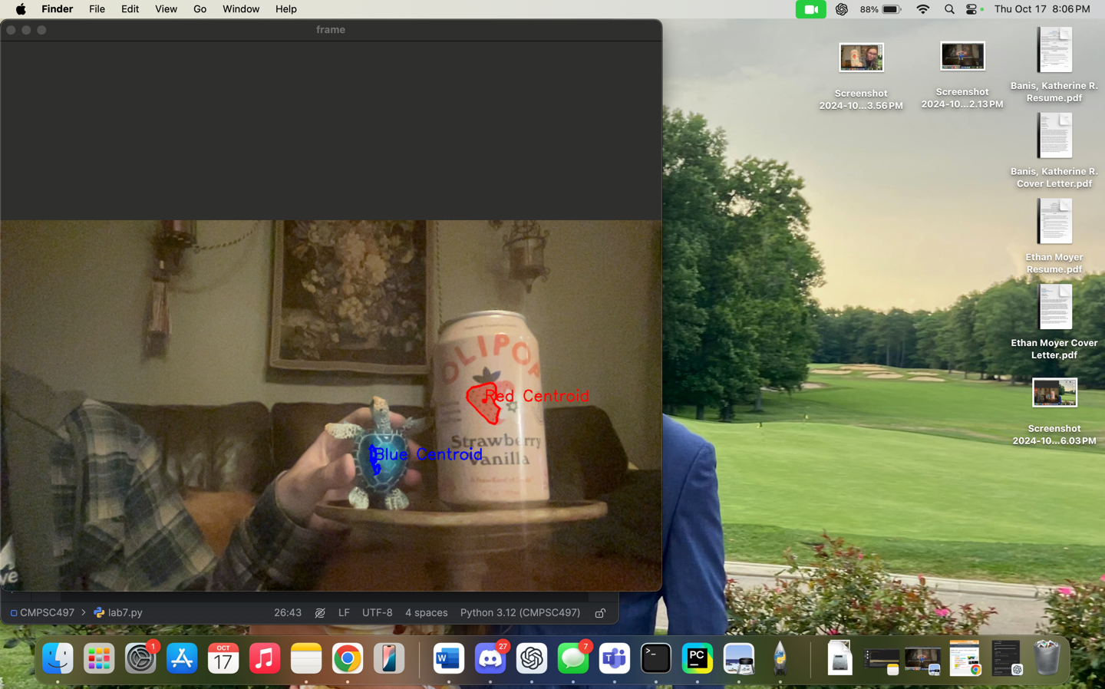

Test 3:

Red soda can and blue turtle.

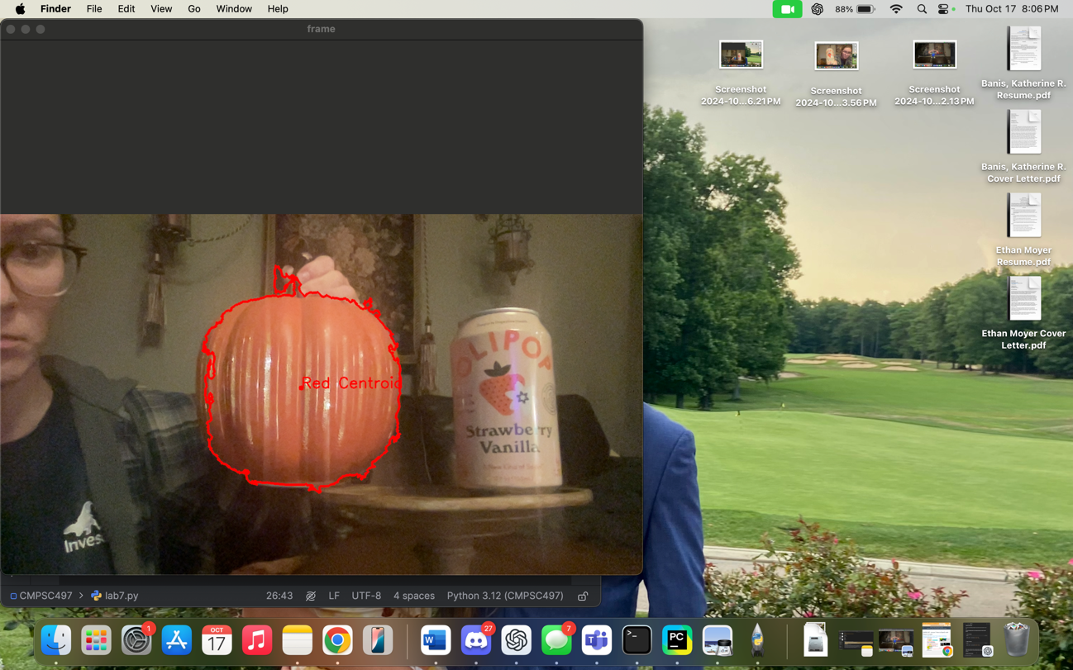

Test 4: Small red fake pumpkin and red soda can.

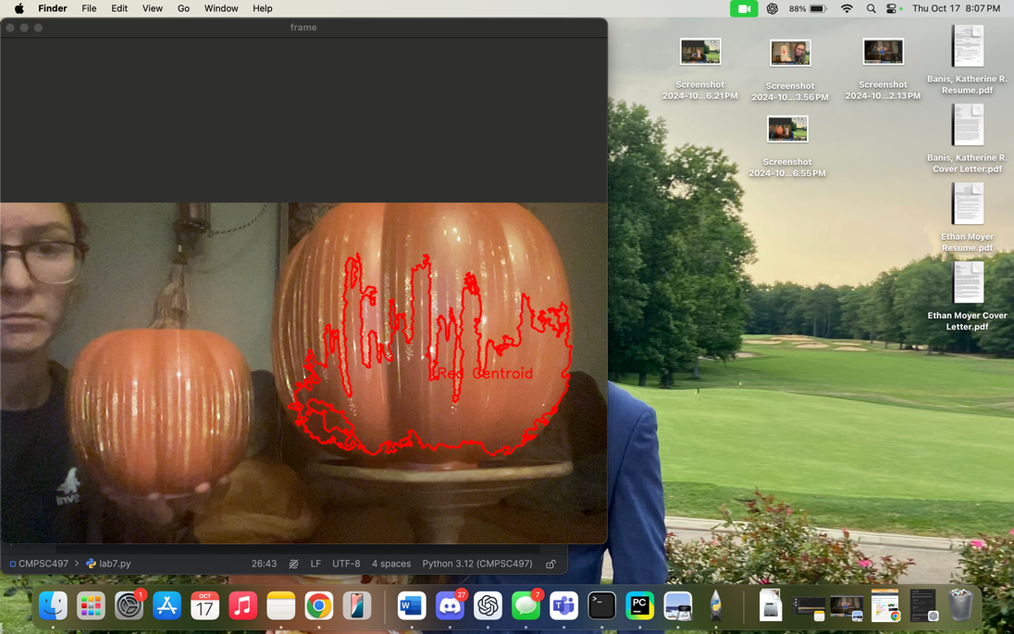Test 5:

Small red fake pumpkin and large red fake pumpkin.

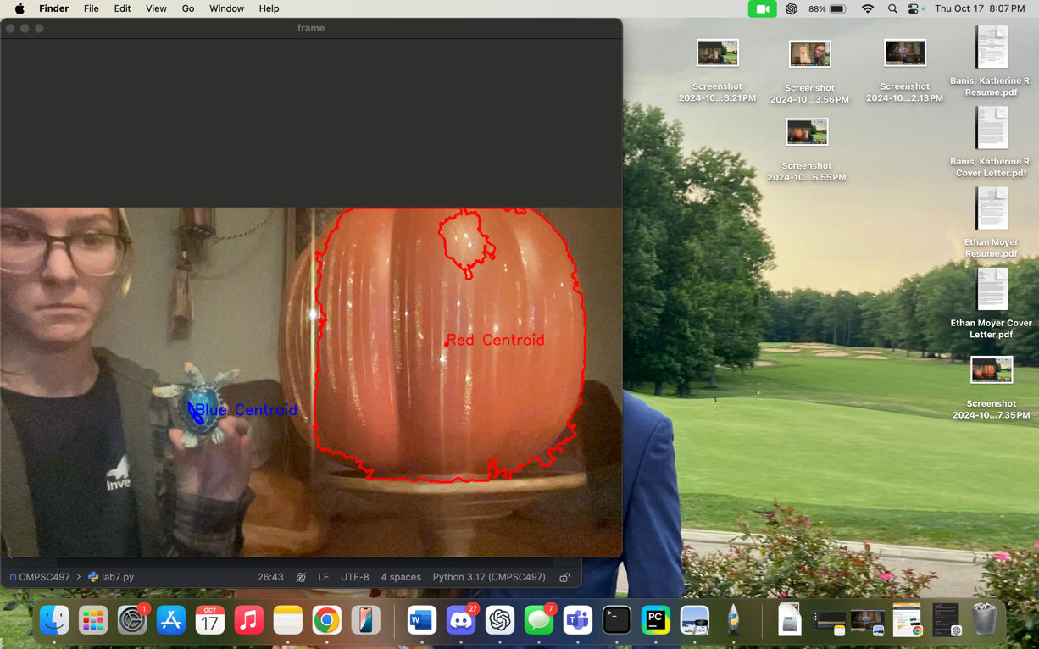

Test 6:

Large red fake pumpkin and blue turtle.

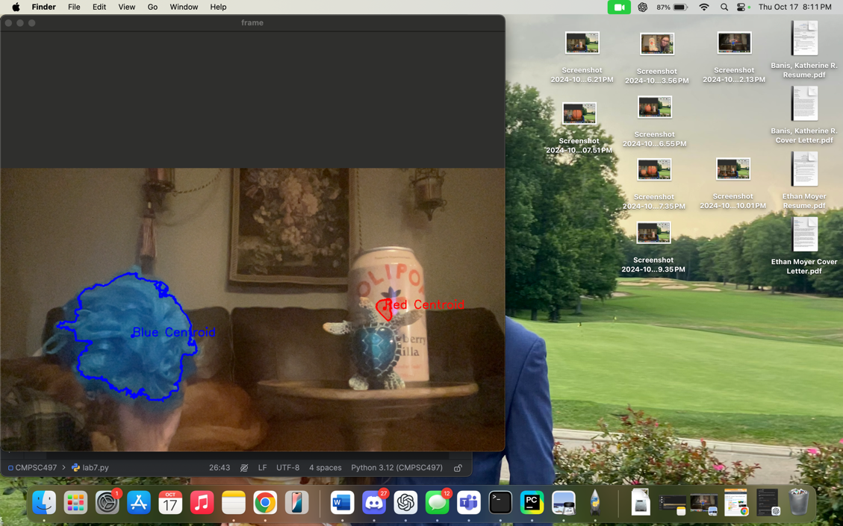Test 7:

Blue luffa, blue turtle, and red soda can.

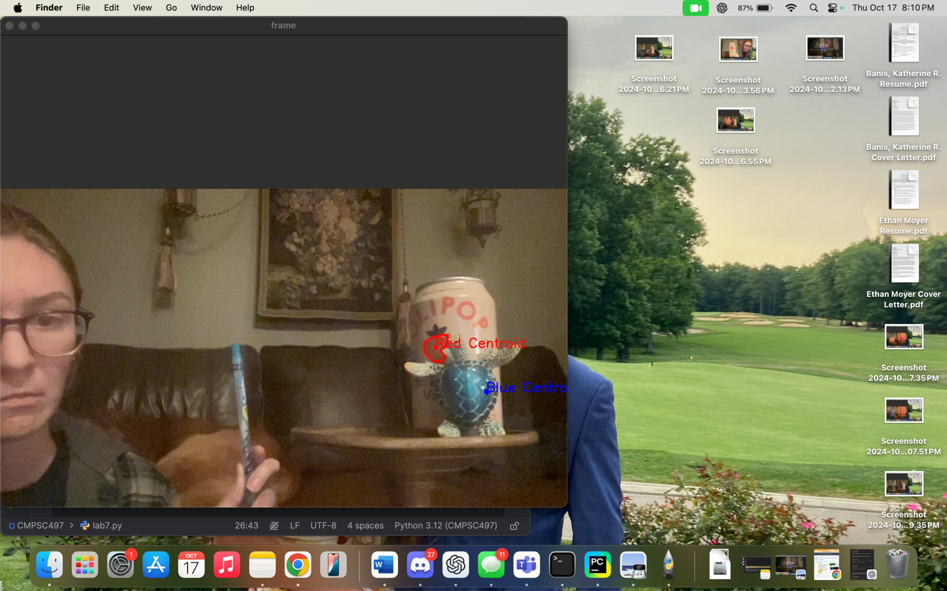

Test 8:

Blue turtle, blue colored pencil, and red soda can.

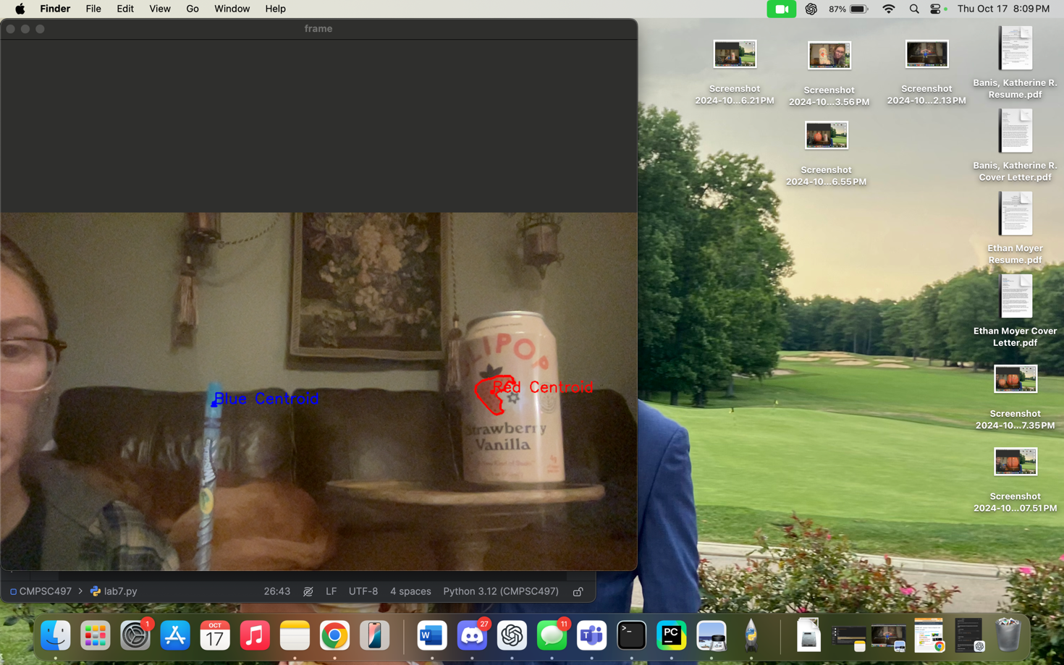

Test 9:

Blue colored pencil and red soda can.

**Conclusion:**

So first I wanted to test that the program worked so I took the OLIPOP strawberry vanilla soda can that I was drinking and checked to see the red strawberry on the can was detected. This was successful and also helped as it was the same color as the OLIPOP text on the can and only the strawberry was detected. I also ran into the issue where my skin would constantly be detected as red. So I tried to modify the range of red in HSV in the code to not detect my skin. This did help a little.

Next, I tested blue and grabbed a green turtle with a blue shell and that was also successful. The centroid was constantly moving on the turtle’s shell. I believe this was due to my movement and the lighting and shadows. I also needed to modify the range of blue in HSV as it wasn’t detecting the blue shell as clearly as I wanted it to.

Then I showed the both the turtle and the soda can to the camera to check that both red and blue could be detected simultaneously. This was also a success.

Next, I needed to check that the program would only detect the largest red object. In this case, I compared a small pumpkin and the soda can. This was a success as pumpkin was detected and the strawberry on the soda can was not. I then removed the soda can and replaced it with a much larger pumpkin and it switched to only detect the large pumpkin and not the small pumpkin. And again, I held up the turtle to check that it would still detect both blue and red objects.

Similarly, I checked that the program would only detect the largest blue object. In this case, I took a blue luffa and the turtle, and successfully, only the blue luffa was detected as it was larger than the turtle. Then I dropped the luffa and held up a small blue colored pencil, and the program successfully switched from the luffa to detect the blue turtle. To check that the blue colored pencil could be detected, I held it up on its own and the tip of the colored pencil was detected.

**Python Code:**

import cv2 as cv  
import numpy as np  
  
# function to find largest contour and centroid  
def find_largest_contour(mask):  
 contours, _ = cv.findContours(mask, cv.RETR_EXTERNAL, cv.CHAIN_APPROX_SIMPLE)  
 if len(contours) > 0:  
 largest_contour = max(contours, key=cv.contourArea)  
 M = cv.moments(largest_contour)  
 if M["m00"] != 0:  
 cx = int(M["m10"] / M["m00"])  
 cy = int(M["m01"] / M["m00"])  
 return largest_contour, (cx, cy)  
 return None, None  
  
cap = cv.VideoCapture(0)  
while(1):  
 # Take each frame  
 _, frame = cap.read()  
  
 # Convert BGR to HSV  
 hsv = cv.cvtColor(frame, cv.COLOR_BGR2HSV)  
  
 # define range of blue color in hsv  
 lower_blue = np.array([100, 100, 100])  
 upper_blue = np.array([130, 255, 255])  
  
 # define range of red color in hsv  
 lower_red = np.array([0, 120, 70])  
 upper_red = np.array([10, 255, 255])  
  
 # threshold the hsv image to get only blue and red colors  
 mask_blue = cv.inRange(hsv, lower_blue, upper_blue)  
 mask_red = cv.inRange(hsv, lower_red, upper_red)  
  
 # combine masks  
 mask_combined = cv.bitwise_or(mask_blue, mask_red)  
 largest_mask = np.zeros_like(mask_combined)  
  
 # find largest blue object  
 largest_blue_contour, blue_centroid = find_largest_contour(mask_blue)  
 if largest_blue_contour is not None:  
 cv.drawContours(frame, [largest_blue_contour], -1, (255, 0, 0), 3)  
 cv.circle(frame, blue_centroid, 5, (255, 0, 0), -1)  
 cv.putText(frame, "Blue Centroid", blue_centroid, cv.FONT_HERSHEY_SIMPLEX, 1, (255, 0, 0), 2)  
  
 # find largest red object  
 largest_red_contour, red_centroid = find_largest_contour(mask_red)  
 if largest_red_contour is not None:  
 cv.drawContours(frame, [largest_red_contour], -1, (0, 0, 255), 3)  
 cv.circle(frame, red_centroid, 5, (0, 0, 255), -1)  
 cv.putText(frame, "Red Centroid", red_centroid, cv.FONT_HERSHEY_SIMPLEX, 1, (0, 0, 255), 2)  
  
 # show original frame with annotations  
 cv.imshow('frame', frame)  
  
 k = cv.waitKey(5) & 0xFF  
 if k == 27: # escape key is 27; space is 32, etc  
 break  
  
cap.release()  
cv.destroyAllWindows()